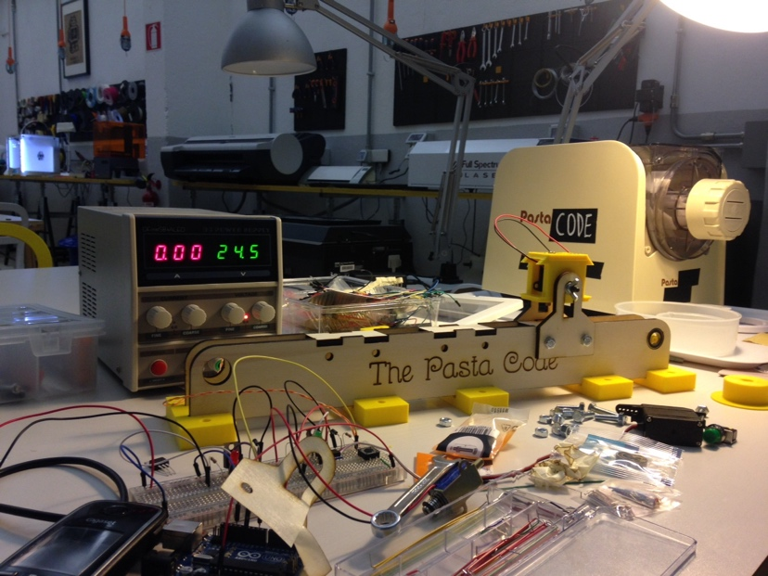
Professional Makerspace

Rome, Italy

I would occasionally bring my daughter to our local library to play in the makerspace area it offered on Saturday mornings. There was a lego table, a computer table, a table with a bunch of random electronic parts, and a pile of large wooden boards with ropes and hooks on the center floor. Anyone could jump in and play, create, and move on. Parents played too, and there was a staff member overseeing the room. This was in the Bay Area of Northern California.
In search of Makerspaces in the center of the Eternal City, I found no such Makerspaces. Instead, I found a robust co-working culture where independent professionals and startup companies shared spaces, equipment, and knowledge. The resources in these spaces varied from a handful of tables to basic office equipment and event spaces to full blown Makerspaces that catered to various sectors of industry. One such Makerspace is called Famo Cose, which means “We Make Things.”



I paid a visit to Famo Cose, a private-sector Makerspace created in 2014. When I entered, I found an open workspace with tables and computers and various tools and printers that lined the walls. Two men peered down from a side loft, but no one else was in the workspace on this Friday morning in early March. Luca Magarò, the owner of Famo Cose, came down to meet me and offered me a tour of the space (as well as a coffee).
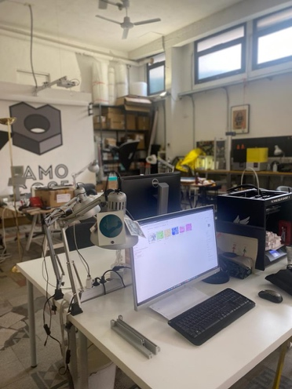
The main space was used for both independent and collaborative work as well as workshops. It was equipped with computers and lined with 3D printers, laser cutters, and other tools.
He showed me the carpentry room with its drill bench, different types of saws, compressors, and a welder. And he then brought me into a room that doubled as a paint room and a darkroom.
Luca explained the necessity of keeping projects that make dust (carpentry projects) and those that are sensitive to dust (painting and photography) in separate, enclosed rooms. There was also a nook with couches to relax on as well as a loft that housed a small kitchen for meal preparation during breaks.
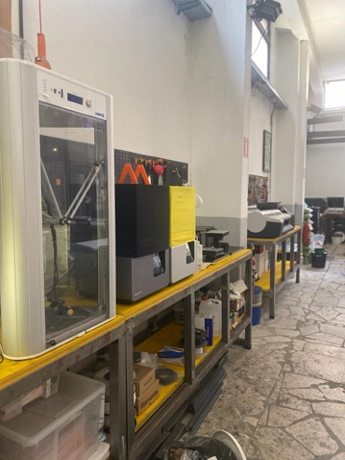
Famo Cose is not designed for young students, Luca explained as he showed me the workshop space. Rather, it is a creative space for designers, engineers, architects, craftsmen, and startup companies to share equipment, prototype ideas, create products, and facilitate cross-sector innovation and collaboration.
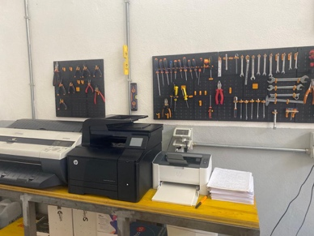
Famo Cose offers workshops as needed by clients as well as consulting on the marketing and financing aspects of startups. Luca explained that they held workshops for students in the past, but that they had to downsize within the last five years as local schools now have FabLabs (digital fabrication laboratories, a type of Makerspace) in their institutions. The current obstacle in education, he explained, is educating teachers on how to use the tools in their FabLab. Collaborations between Famo Cose and school districts now take the form of teacher training. Luca Magarò explains that they will go to schools to train teachers on the equipment so that they are, in turn, better equipped to teach students.


This information lines up with my research as I have found several sources discussing the Makerspace movement in education from 2014 to 2018. During this time, schools were doing what they called “pop-up makers” and “mini-makers,” certain days they would set up makerspaces for students to explore and learn as they did not have fully funded makerspaces. Some local libraries did this as well on a temporary basis.
Roma Makers, a project that ended in 2019 with the establishment of FabLab Roma, initially set out to bring “mini-makers” to 20 schools in the Rome area (Baeck and Romano, 2017).
FabLab Roma is much more than a physical space(s). It’s a network of private companies working together to promote digital innovation to a community of young professionals.
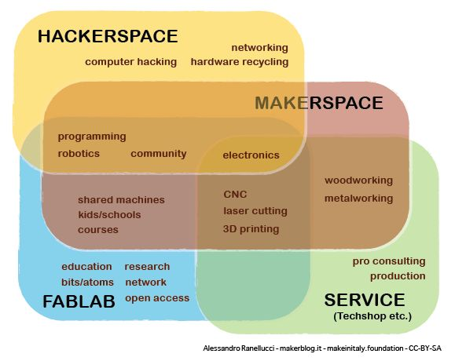
One partner is Chirale Academy, which offers online and in-person professional training courses in science, technology, and arts. Courses such as Fashion Tech, Professional Laser Cutting, Circuit Board Design, and Machine Learning are modestly priced at 15-35 euros. I had the chance to check out its free online course, Introduction to Quantum Computing!

Famo Cose offered me a very different point of view of the value of a Makerspace, as did my experience exploring FabLab Roma’s evolution and online offerings. Famo Cose was clearly a place for professionals to work on their projects and prototype their products, and FabLab Roma clearly focused on professional development and helping the community to realize their professional aspirations.
My experience with Makerspaces in the U.S. has always been within educational contexts, and while they exist in some North American colleges and universities, they are usually much more embedded into the primary education experience.

In Rome, while Makerspaces are also in education, they are being leveraged by a robust co-working culture for professional training and collaboration, support hubs that help independent designers, artists, engineers, and startup companies actualize their ideas and bring innovation to the community.

Other important sources of the Makerspace movement in Rome, Italy:
- Maker Faire Rome, the European Edition, October 20-22, 2023
- Fondazione Mondo Digitale, pioneers of the Innovation Gyms in the outer Rome area

